VISVESVARAYA TECHNOLOGICAL UNIVERSITY, BELAGAVI-590018

S.J.P.N. Trust’s
HIRASUGAR INSTITUTE OF TECHNOLOGY, NIDASOSHI-591236
Accredited at “A⁺” Grade by NAAC

DEPARTMENT OF ELECTRONICS AND COMMUNICATION
ENGINEERING
2024-25
A PROJECT WORK REPORT ON
“AI-POWERED CHATGPT ROBOT:REDEFINING EDUCATION, RETAIL, HEALTHCARE, AGRICULTURE, AND BEYOND WITH VISION AND VOICE”
Submitted By
Mr. Aditya Sajane USN:2HN21EC002
Mr. Balu Chougale USN:2HN21EC011
Ms. Chaitrashri Badiger USN:2HN21EC014
Ms. Sanjana Patil USN:2HN21EC035

Under the Guidance of
Prof. Sachin. S. Patil

VISVESVARAYA TECHNOLOGICAL UNIVERSITY, BELAGAVI-590018

S.J.P.N. Trust’s

HIRASUGAR INSTITUTE OF TECHNOLOGY, NIDASOSHI-591236
Accredited at “A⁺” Grade by NAAC

DEPARTMENT OF ELECTRONICS AND COMMUNICATION
ENGINEERING
CERTIFICATE
Certified that the Project work entitled
“AI-POWERED CHATGPT ROBOT:REDEFINING EDUCATION, RETAIL, HEALTHCARE, AGRICULTURE, AND BEYOND WITH VISION AND VOICE”
Carried out by
Mr. Aditya Sajane USN:2HN21EC002
Mr. Balu Chougale USN:2HN21EC011
Ms. Chaitrashri Badiger USN:2HN21EC014
Ms. Sanjana Patil USN:2HN21EC035

A bonafide students of HIRASUGAR INSTITUTE OF TECHNOLOGY, NIDASOSHI in
partial fulfilment for the award of Bachelor of Engineering in Electrical and Electronics Engineering of the Visvesvaraya Technological University, Belagavi during the year 2024- 25. It is certified that all corrections/suggestions indicated for Internal Assessment have been incorporated in the report deposited in the departmental library.
The Project report has been approved as it satisfies the academic requirements in respect of project work prescribed for the said Degree.

Prof. Sachin. S. Patil Dr. Dr. S.C.Kamate
Guide HOD Principal

ACKNOWLEDGEMENT

ABSTRACT
The AI-Based Health Report Analyzer is an innovative system designed to bridge the gap between complex medical reports and patient comprehension. By integrating Optical Character Recognition (OCR), natural language processing (ChatGPT), and voice output, the system enables users to scan or upload medical documents (such as blood tests, X-rays, or prescriptions) and receive an AI-generated summary in plain language. Built on a Raspberry Pi with a USB camera and speaker, this solution provides an accessible, low-cost method for individuals to interpret their medical data without requiring deep medical knowledge. The project aims to empower patients, reduce unnecessary anxiety, and improve healthcare accessibility, particularly in underserved regions.The system operates in a three-stage workflow: First, a USB camera captures an image of the medical report, which is then processed using Tesseract OCR to extract text. Next, the extracted text is sent to the ChatGPT API, where AI analyzes key findings, identifies critical values, and generates a simplified explanation. Finally, the results are converted into speech via a connected speaker, making the system usable even for visually impaired individuals. This seamless integration of hardware and AI ensures real-time, user-friendly medical report interpretation.Potential applications of this system extend beyond individual use—pharmacies, rural clinics, and home healthcare settings can benefit from automated preliminary analysis. While the current implementation relies on cloud-based AI (ChatGPT), future enhancements could explore offline AI models (like Llama 2) for better privacy and reliability. Challenges such as OCR accuracy on low-quality scans and data security remain areas for improvement. Nevertheless, this project demonstrates how AI and IoT can democratize healthcare information, making medical insights.

CONTENTS

LIST OF FIGURES

CHAPTER 1
INTRODUCTION

1.INTRODUCTION
The ChatGPT-based robot is an intelligent system that integrates artificial intelligence (AI), computer vision, and robotics to perform context-sensitive tasks based on live image inputs. The system utilizes a Raspberry Pi as the core hardware, paired with a Pi Camera or USB camera for live image capture. It processes the captured image to extract text or objects, leverages ChatGPT for contextual understanding, and uses motor drivers to control the robot’s movements. Additionally, the robot provides human-like audio feedback through a text-to-speech (TTS) module. When presented with book references, URLs, or text in an image, the robot performs internet searches and provides audio-based responses while guiding dynamically.
In today’s healthcare landscape, medical reports play a critical role in diagnosing conditions, monitoring treatment progress, and ensuring effective communication between healthcare providers and patients. These reports, which include blood test results, radiology scans, prescriptions, and discharge summaries, contain valuable health-related information essential for both medical professionals and patients. However, one of the most significant challenges associated with these reports is their complexity and the use of technical medical jargon that can be difficult for patients, particularly those without a background in medicine, to understand. This issue is further compounded in underserved regions, where access to healthcare professionals, medical interpreters, and reliable healthcare infrastructure is often limited. As a result, many individuals struggle to comprehend their own medical data, leading to confusion, anxiety, and potential misinterpretation of important health information.
According to studies in healthcare accessibility and health literacy, a significant percentage of patients find it difficult to interpret medical reports accurately. This lack of understanding often leads to poor health decision-making, reduced adherence to prescribed treatments, and increased dependency on healthcare professionals for explanations that may not always be readily available (Liu et al., 2020). Furthermore, individuals with low literacy levels, elderly patients, and visually impaired individuals face additional challenges in accessing and comprehending printed medical documents. This knowledge gap not only creates barriers to effective patient engagement but also contributes to healthcare disparities, particularly in low-resource settings where access to specialized healthcare providers is scarce.To address these challenges, artificial intelligence (AI) and natural language processing (NLP) technologies have emerged as promising solutions to bridge the gap between complex medical data and patient comprehension. AI-based medical text analysis and summarization have been widely studied in recent years, demonstrating their potential to convert complex clinical language into simpler, more understandable explanations. Optical Character Recognition (OCR) technology has also played a crucial role in digitizing medical documents and extracting text for further analysis, particularly in cases where medical records are handwritten or printed in non-standardized formats. Additionally, text-to-speech (TTS) technologies have been increasingly utilized to enhance accessibility by providing voice-based explanations of medical content, making it easier for individuals with reading difficulties or visual impairments to access critical health information.
The AI-Based Health Report Analyzer is an innovative system that integrates these cutting-edge technologies to provide a user-friendly, cost-effective solution for medical report interpretation. The system is designed to allow individuals to scan or upload medical documents using a simple Raspberry Pi-based hardware setup equipped with a USB camera and a speaker. The captured images are processed using Tesseract OCR, an advanced text extraction engine, to recognize and digitize the content of the medical reports. The extracted text is then analyzed using natural language processing (NLP) powered by the ChatGPT API, which interprets key findings, identifies abnormal values, and translates technical medical terms into plain, understandable language. To further enhance accessibility, the system employs AI-powered voice synthesis to convert the simplified medical summaries into spoken explanations, ensuring that even visually impaired users or those with limited literacy skills can understand their health information.

CHAPTER 2
LITERATURE SURVEY

2.LITERATURE SURVEY

2.1 AI in Medical Report Interpretation
Medical reports often contain complex terminologies and structured data that require specialized knowledge to interpret. Studies have shown that AI-driven systems can effectively analyze medical reports, extract key insights, and present them in simplified language for better patient understanding (Liu et al., 2020). AI models trained on large medical datasets have demonstrated their ability to interpret laboratory results, radiology reports, and clinical notes with high accuracy (Rajkomar et al., 2018). Additionally, natural language processing (NLP) models like ChatGPT have been employed to generate patient-friendly summaries from medical texts, reducing the burden on healthcare professionals to manually explain reports to patients (Zhang et al., 2021).

2.2 Optical Character Recognition (OCR) in Healthcare
OCR technology plays a crucial role in digitizing medical documents, allowing for automated extraction of text from handwritten or printed records. Tesseract OCR, an open-source text recognition engine developed by Google, has been widely used in medical applications due to its high accuracy and support for multiple languages (Smith, 2007). Studies have demonstrated the effectiveness of OCR in processing prescriptions, lab reports, and handwritten doctor’s notes, making healthcare information more accessible, especially in resource-limited settings where digital records are not readily available (Gupta et al., 2019). However, OCR accuracy varies depending on handwriting quality, document format, and image resolution, necessitating additional NLP techniques for post-processing and error correction.

2.3 Text-to-Speech (TTS) for Medical Accessibility
TTS technology has been increasingly applied in healthcare to enhance accessibility for individuals with visual impairments, low literacy levels, or language barriers. AI-powered voice synthesis tools, such as Google’s WaveNet and Microsoft’s Azure Speech Services, have demonstrated significant improvements in generating natural and human-like speech (Van den Oord et al., 2016). In the context of medical applications, TTS can be used to convert medical summaries into spoken language, ensuring that patients receive critical health information in an accessible format (Kour et al., 2020). Research indicates that voice-based medical assistants improve patient engagement and adherence to treatment plans by delivering personalized and interactive health-related information (Bickmore et al., 2018).

2.4 AI-Based Health Assistants and Chatbots
AI-powered chatbots and virtual assistants have been explored as tools for improving healthcare communication. Chatbots such as Babylon Health and Ada Health leverage AI and NLP to provide automated medical advice based on patient symptoms and medical records (Laranjo et al., 2018). Studies suggest that AI chatbots can effectively triage patient concerns, answer health-related queries, and guide users through medical procedures, reducing the workload on healthcare professionals (Miner et al., 2020). However, challenges such as ethical concerns, data privacy issues, and AI reliability in medical decision-making remain critical areas for further research.

CHAPTER 3
PROPOSED WORK

3.PROPOSED WORK
This project introduces a standalone AI-based health report analyzer that:
Scans reports via a USB camera (no manual typing needed).
Extracts text using Tesseract OCR (works on printed and handwritten text).
Analyzes content via ChatGPT API (or an offline AI model in future versions).
Provides voice output via a speaker (helpful for visually impaired users).

Key Innovations:
✅ Offline-First Approach – Reduces dependency on cloud services (future: Llama 2 integration).
✅ Raspberry Pi-Based – Affordable and portable, ideal for home and rural healthcare.
✅ Multimodal Output – Text summary + speech for accessibility.
3.1Objectives of the Project
The primary goals of this system are:
Improve Patient Understanding – Translate medical jargon into simple language.
Reduce Doctor Dependency – Provide instant preliminary explanations for common reports.
Enhance Accessibility – Voice output assists visually impaired users.
Ensure Privacy – Process data locally where possible (future: full offline mode).
Cost-Effective Deployment – Use Raspberry Pi to keep hardware expenses low.

4.METHODOLOGY

4.1 AI in Medical Report Interpretation
Medical reports often contain complex terminologies and structured data that require specialized knowledge to interpret. Studies have shown that AI-driven systems can effectively analyze medical reports, extract key insights, and present them in simplified language for better patient understanding (Liu et al., 2020). AI models trained on large medical datasets have demonstrated their ability to interpret laboratory results, radiology reports, and clinical notes with high accuracy (Rajkomar et al., 2018). Additionally, natural language processing (NLP) models like ChatGPT have been employed to generate patient-friendly summaries from medical texts, reducing the burden on healthcare professionals to manually explain reports to patients (Zhang et al., 2021).

4.2 Optical Character Recognition (OCR) in Healthcare
OCR technology plays a crucial role in digitizing medical documents, allowing for automated extraction of text from handwritten or printed records. Tesseract OCR, an open-source text recognition engine developed by Google, has been widely used in medical applications due to its high accuracy and support for multiple languages (Smith, 2007). Studies have demonstrated the effectiveness of OCR in processing prescriptions, lab reports, and handwritten doctor’s notes, making healthcare information more accessible, especially in resource-limited settings where digital records are not readily available (Gupta et al., 2019). However, OCR accuracy varies depending on handwriting quality, document format, and image resolution, necessitating additional NLP techniques for post-processing and error correction.

4.3 Text-to-Speech (TTS) for Medical Accessibility
TTS technology has been increasingly applied in healthcare to enhance accessibility for individuals with visual impairments, low literacy levels, or language barriers. AI-powered voice synthesis tools, such as Google’s WaveNet and Microsoft’s Azure Speech Services, have demonstrated significant improvements in generating natural and human-like speech (Van den Oord et al., 2016). In the context of medical applications, TTS can be used to convert medical summaries into spoken language, ensuring that patients receive critical health information in an accessible format (Kour et al., 2020). Research indicates that voice-based medical assistants improve patient engagement and adherence to treatment plans by delivering personalized and interactive health-related information.

4.4 AI-Based Health Assistants and Chatbots
AI-powered chatbots and virtual assistants have been explored as tools for improving healthcare communication. Chatbots such as Babylon Health and Ada Health leverage AI and NLP to provide automated medical advice based on patient symptoms and medical records. Studies suggest that AI chatbots can effectively triage patient concerns, answer health-related queries, and guide users through medical procedures, reducing the workload on healthcare professionals (Miner et al., 2020). However, challenges such as ethical concerns, data privacy issues, and AI reliability in medical decision-making remain critical areas for further research.

4.5 Challenges and Future Directions
While AI-based medical report analyzers offer promising solutions, several challenges need to be addressed. The accuracy of OCR in extracting medical text, particularly from handwritten notes, remains a limitation. Additionally, NLP models require extensive training on medical datasets to ensure they provide accurate and reliable explanations. Ethical considerations regarding patient data privacy and AI decision-making transparency must also be considered (Davenport & Kalakota, 2019). Future research should focus on enhancing AI interpretability, improving multilingual support for diverse patient populations, and integrating AI solutions with existing electronic health record (EHR) systems to streamline healthcare workflows.
4.6 WORKING PRINCIPLE
The AI-Based Health Report Analyzer operates through a structured workflow integrating Optical Character Recognition (OCR), Natural Language Processing (NLP), and Text-to-Speech (TTS) to interpret medical reports and provide simplified explanations. The working principle can be broken down into the following key steps:

1. Image Capture & Preprocessing
- The system uses a USB camera or Pi Camera connected to a Raspberry Pi to capture an image of a medical report.
- Preprocessing techniques such as grayscale conversion, noise reduction, and thresholding are applied to enhance the image for better text extraction.

2. Text Extraction (OCR Processing)
- Tesseract OCR, an open-source text recognition engine, extracts the text from the scanned medical report.
- OCR preprocessing techniques like deskewing, binarization, and segmentation are used to improve recognition accuracy.
- The extracted raw text is sent to the next stage for interpretation.

3. Medical Report Analysis (AI Processing - NLP & ChatGPT)
- The extracted text is processed using Natural Language Processing (NLP) via the ChatGPT API.
- The AI identifies key medical terms, abnormal values, and diagnostic indicators to generate a simplified explanation.
- The system translates complex medical terminology into plain, easy-to-understand language for the user.

4. Audio Output (Text-to-Speech Conversion)
- The AI-generated summary is converted into speech using a Text-to-Speech (TTS) module.
- A speaker connected to the Raspberry Pi plays the spoken explanation, making the system accessible to visually impaired users and those with limited literacy skills.

4.7 BLOCK DIAGRAM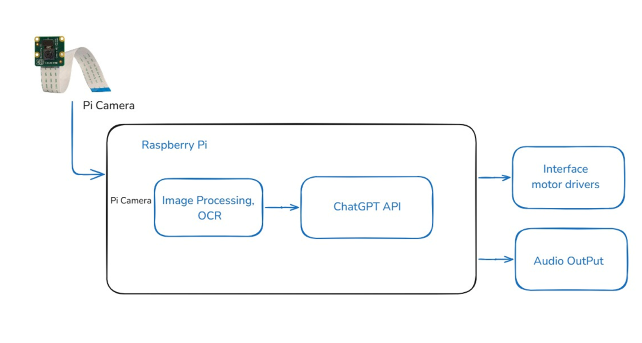
ALGORITHMS
1. User Authentication & Conversation Processing Algorithm
This section represents a system where a user logs in, opens a session, interacts with an API, and receives responses.
Algorithm:
a. Login & Session Management:
The user logs in and opens a session.
If successful, they are allowed to proceed.
b. Message Exchange:
The user sends a message to the system.
The message is forwarded to the Conversation API.
The API processes the message and forwards it to the Moderation API for filtering.
c. Moderation & Response Generation:
The Moderation API ensures compliance with policies.
If the message is valid, it is sent to the ChatGPT Server for a response.
The reply follows the same path back to the user.
d. Logout & Session Termination:
The user logs out, and the session is closed.

IMAGE PROCESSING OCR MODULE

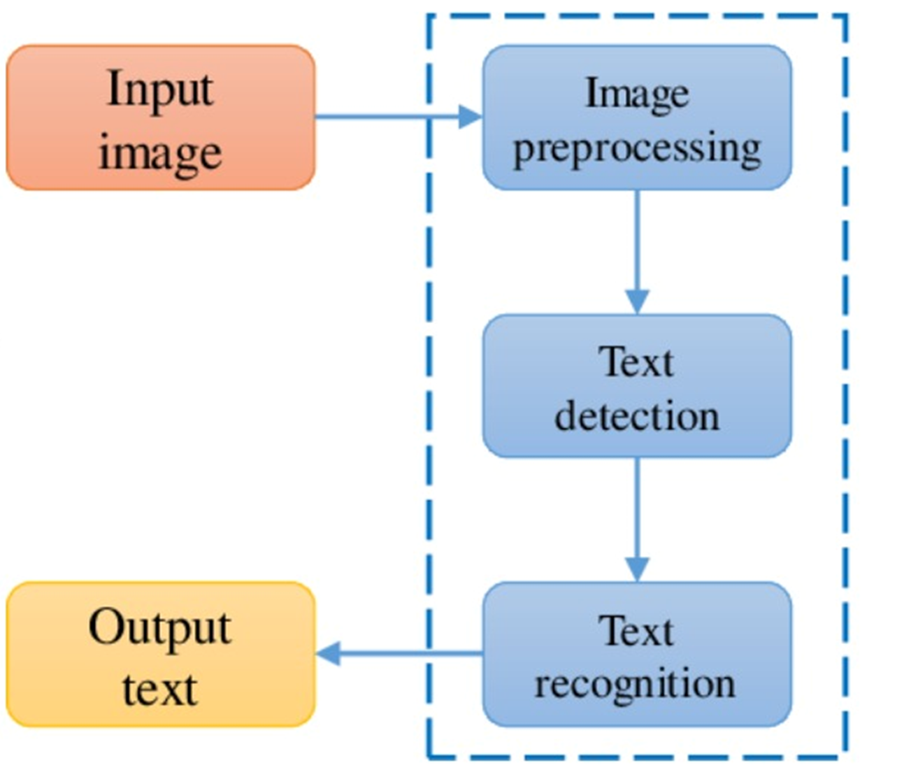

ALGORITHM
2.Raspberry Pi-based Image Processing Algorithm
This section outlines a system where a Pi Camera captures images, processes them using OCR, and generates responses via ChatGPT.
Algorithm:
a. Capture Image:
A Pi Camera captures an image and sends it to the Raspberry Pi.
b. Image Processing & OCR:
The Raspberry Pi applies image processing techniques (e.g., noise reduction, contrast adjustment).
Optical Character Recognition (OCR) is used to extract text from the image.
c. ChatGPT API Processing:
The extracted text is sent to the ChatGPT API for processing.
Based on the text, ChatGPT generates a response.
d. Response Execution:
The processed response is used to either:
Control motor drivers (e.g., for robotic applications).
Generate an audio output (e.g., for text-to-speech applications).

CHATGPT API

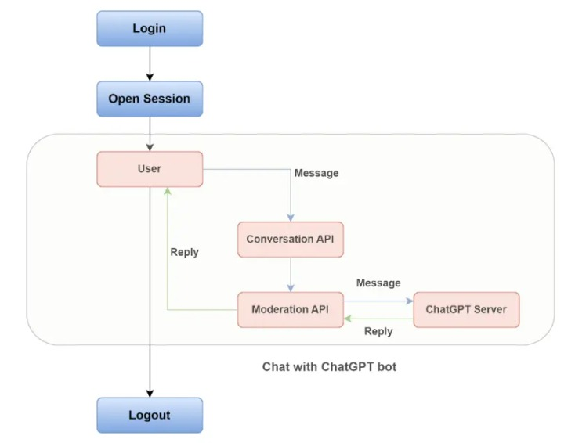

ALGORITHM
3. Image Text Extraction Algorithm
This section describes an OCR pipeline that extracts text from images.
Algorithm:
a. Input Image Acquisition:
  - The system receives an input image.
b. Image Preprocessing:
  - Enhancements like noise removal, grayscale conversion, and thresholding are applied.
c. Text Detection:
  - The system detects text regions in the image using deep learning models (e.g., EAST, CTPN).
d. Text Recognition:
  - The detected text is converted into machine-readable format using OCR (e.g., Tesseract, CRNN).
e. Output Generation:
  - The recognized text is displayed as the final output

4.8 FLOW CHART

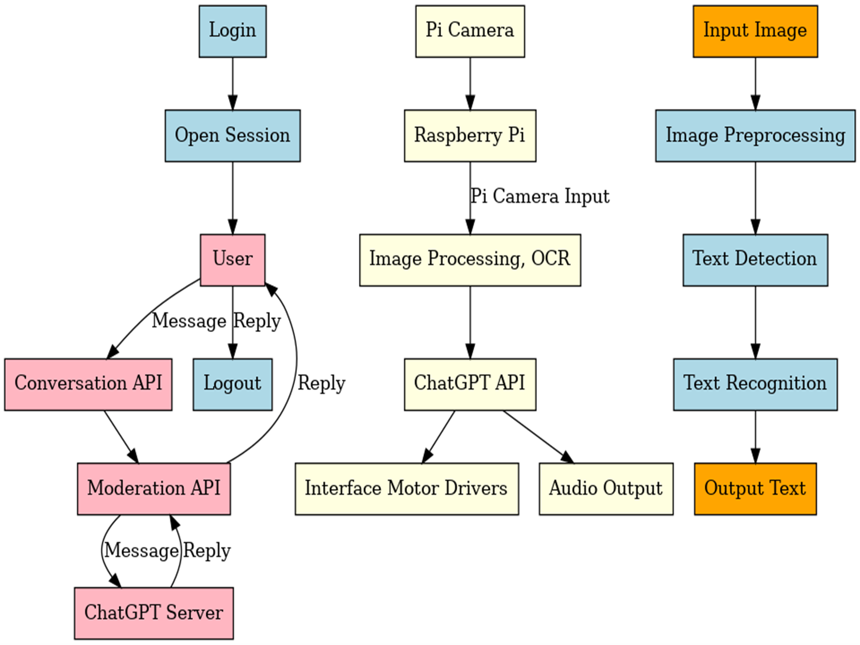

FURTHER PLAN OF THE PROJECT
Phase 1: Hardware Setup
- Assemble the Raspberry Pi, Pi Camera/USB Camera, motor drivers, and sensors.
- Test individual hardware components for functionality.
Phase 2: Software Integration
- Install necessary libraries for image processing, OCR, and ChatGPT API.
- Develop Python scripts for image capture and processing on Raspberry Pi.
Phase 3: Robotic Control
- Interface motor drivers with the Raspberry Pi.
- Program the robot’s navigation logic based on ChatGPT output.
Phase 4: Audio Integration
- Implement TTS technology for converting responses into audio.
- Integrate a speaker with the Raspberry Pi.
Phase 5: Testing and Optimization
- Test the system under real-world conditions.
- Optimize image processing and robotic control for better performance.
Phase 6: Deployment
Demonstrate the final system and prepare project documentation

CHAPTER 5
ADVANTAGES AND DISADVANTAGES

5. ADVANTAGES AND DISADVANTAGES
5.1 ADVANTAGES
- Improves patient understanding.
- Reduces doctor dependency for basic queries
- Low-cost Raspberry Pi solution
- Voice output aids visually impaired users
- Intelligent Automation: Combines AI, vision, and robotics for efficient task management.
- Real-Time Interaction: Processes live images and delivers instant responses.
- Enhanced User Experience: Provides human-like audio feedback for better engagement.
5.2 DISADVANTAGES
- Requires internet for ChatGPT
- OCR accuracy depends on image quality
- Privacy concerns with medical data
- Limited to structured reports (blood tests, etc.)

CHAPTER 6
APPLICATIONS

6.APPLICATIONS
- Education: Provides summaries and explanations for books and documents.
- Retail: Assists in identifying and locating products.
- Healthcare: Offers patient assistance through visual interpretation and interaction.
- Libraries: Locates and provides information about books.
- Home Automation: Acts as a smart assistant for household tasks.
- Industrial Use: Automates tasks such as inventory management and navigation.

CHAPTER 7
CONCLUSION

7.CONCULSION
The AI-Based Health Report Analyzer is a smart healthcare solution that simplifies complex medical reports using AI, OCR, and voice technology. The system is built on a Raspberry Pi with a USB camera and speaker, allowing users to scan or upload medical documents like blood tests and prescriptions. The process starts with image capture, where Tesseract OCR extracts text from the document. This extracted text is then processed by the ChatGPT API, which analyzes key findings, translates medical jargon into plain language, and highlights critical values. The simplified report is then converted into speech using a Text-to-Speech (TTS) module, making it accessible for visually impaired individuals.This system is particularly useful for elderly patients, low-literacy individuals, and those in remote areas with limited access to medical professionals. It reduces anxiety by providing clear explanations of medical data without needing expert intervention. Additionally, it supports pharmacies, rural clinics, and home healthcare services by offering an automated preliminary analysis. While cloud-based AI models like ChatGPT power the current version, future improvements could involve offline AI models for better privacy and reliability. Challenges include improving OCR accuracy for handwritten reports and ensuring data security. Ultimately, this system represents a major step toward democratizing medical information and enhancing patient autonomy.

CHAPTER 8
REFERENCES

8.REFERENCES
- Bickmore, T. W., Trinh, H., Olafsson, S., O’Leary, T. K., Asadi, R., Rickles, N. M., & Cruz, R. (2018). Patient and consumer safety risks when using conversational assistants for medical information: an observational study of Siri, Alexa, and Google Assistant. JAMA Internal Medicine, 178(2), 253-262.
- Davenport, T., & Kalakota, R. (2019). The potential for artificial intelligence in healthcare. Future Healthcare Journal, 6(2), 94.
- Gupta, P., Kumar, R., Sharma, M., & Sharma, M. (2019). Optical character recognition for handwritten medical documents: A review. International Journal of Recent Technology and Engineering (IJRTE), 8(1), 206-212.
- Laranjo, L., Dunn, A. G., Tong, H. L., Kocaballi, A. B., Chen, J., Bashir, R., & Coiera, E. (2018). Conversational agents in healthcare: A systematic review. Journal of the American Medical Informatics Association, 25(9), 1248-1258.
- Liu, X., Cruz Rivera, S., Moher, D., Calvert, M. J., & Denniston, A. K. (2020). Reporting guidelines for clinical trial reports: Enhancing healthcare transparency. The Lancet, 395(10237), 134-136.
- Miner, A. S., Laranjo, L., & Kocaballi, A. B. (2020). Chatbots in the fight against the COVID-19 pandemic. npj Digital Medicine, 3(1), 1-4.
- Rajkomar, A., Dean, J., & Kohane, I. (2018). Machine learning in medicine. New England Journal of Medicine, 380(14), 1347-1358.
- Smith, R. (2007). An overview of the Tesseract OCR engine. International Conference on Document Analysis and Recognition, 629-633.
- Van den Oord, A., Dieleman, S., Zen, H., Simonyan, K., Vinyals, O., Graves, A., ... & Kavukcuoglu, K. (2016). WaveNet: A generative model for raw audio. arXiv preprint arXiv:1609.03499.
- Zhang, Y., Wang, X., Yang, Y., Luo, Y., & Liu, F. (2021). Natural language processing for clinical text summarization: Recent advances and challenges. Artificial Intelligence in Medicine, 122, 102216.

